Shop Nest Performance Report (2016-2018)
1. Top 10 Product Categories by Sales
Insight: The revenue is heavily driven by home and lifestyle products. Categories like Bed, Bath & Table, Health & Beauty, and Computers Accessories consistently rank as top earners.
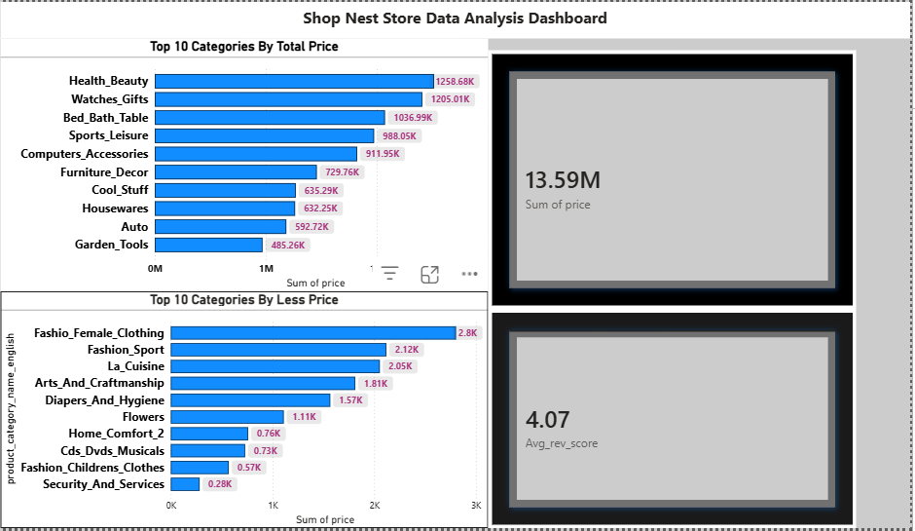
These cluster bar charts represent the top 10 highest and top 10 lowest categories also the card chart represents the sum of price and the average salles by category wise.

2. Delivery Performance (Delayed vs. On-Time)
Insight: While the majority of orders are fulfilled on time, a significant volume of "Delayed" orders was identified.
Visualization Note-this stacked bar represent the delayed and on time order also the month wise data in x axis order id is mention .
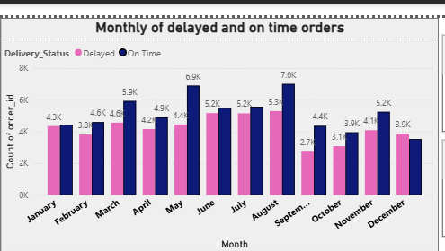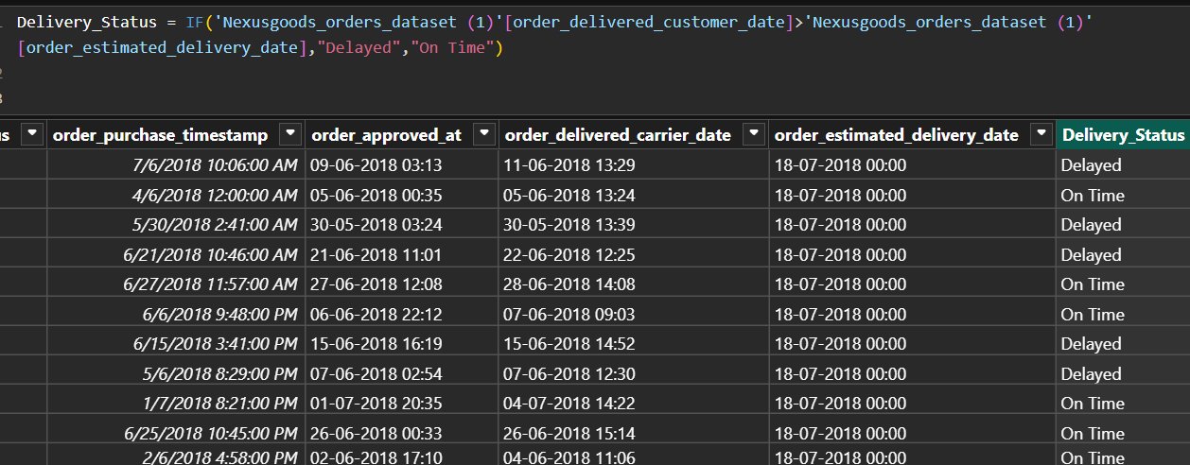
Insight: Order volume grew exponentially through 2017. However, as volume increased, the gap between Estimated and Actual delivery dates widened during peak months.

Pattern: Delays tend to spike during holiday seasons (November/December), suggesting a need for increased carrier capacity during Q4.

4. Customer Payment Preferences
Insight: Credit Card is the dominant payment method, followed by Boleto (a popular Brazilian payment slip).

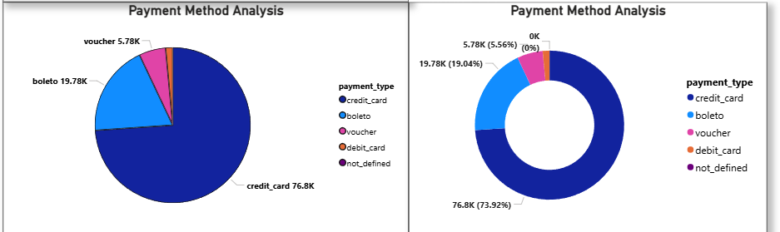

Visualization Note:- This pie chart and Donat chart represent the payment method and the payment type like mostly transitions are done by credit card and the boleto have 2nd number both the charts are representing same data.
Business Action: Ensure the credit card checkout experience is seamless and consider offering "Interest-Free Installments" as this is a key driver for high-value purchases in this market.
6. Product Rating Extremes (Top 10 vs. Bottom 10)
Insight: The Top 10 products often represent niche items with consistent quality. The Bottom 10 products often share common issues such as poor packaging or "mismatch between description and reality."

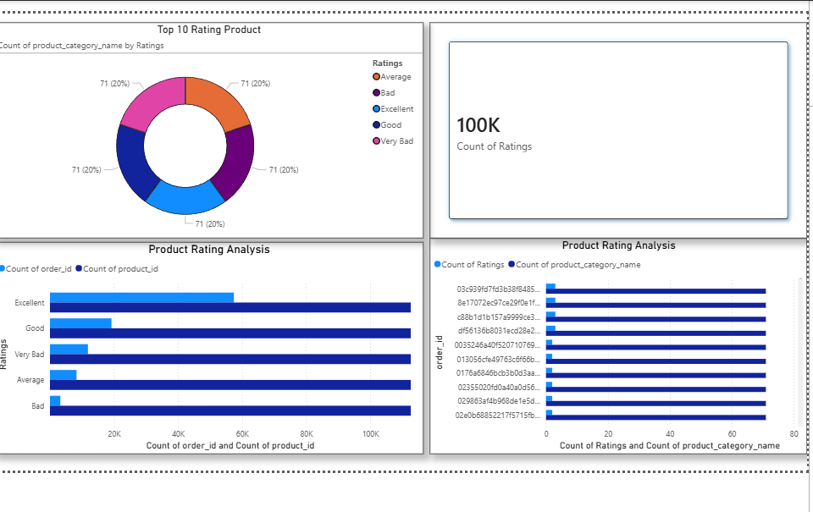
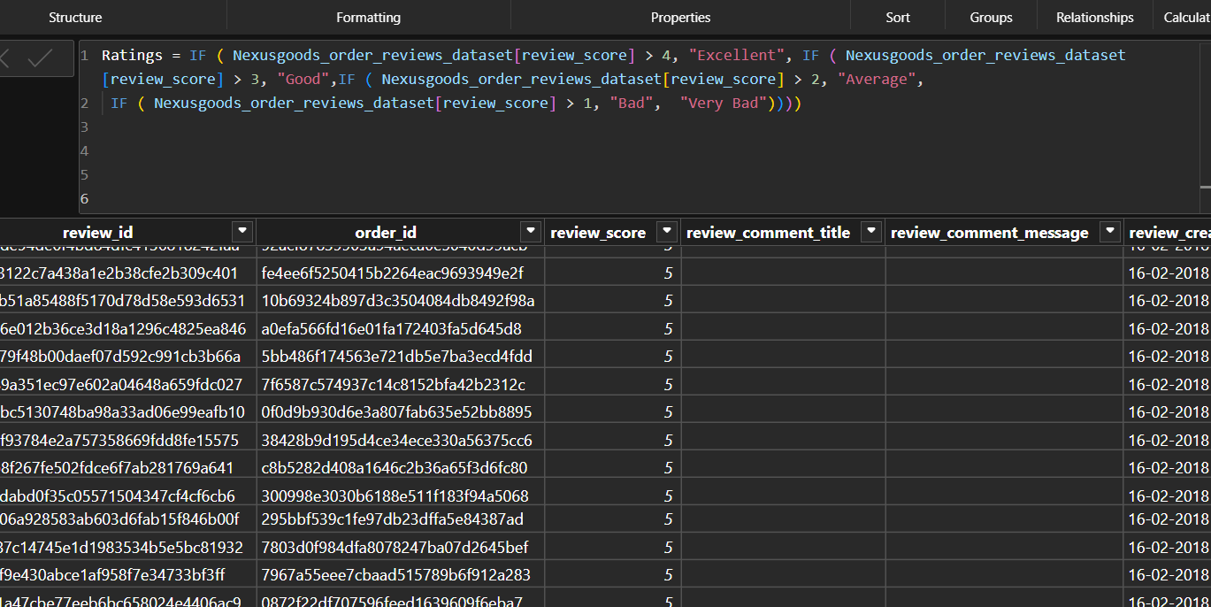
Visualization notes:- All these charts are representing the product review rating data, like bad, good, and excellent decision by the customer review score.

7. Regional Sales Performance (States)

Insight: Sales are highly concentrated in the Southeast region of Brazil. SP (São Paulo) is the undisputed leader, followed by RJ (Rio de Janeiro) and MG (Minas Gerais).
Visualization Note:- this Field map chart representing the seller state and another line and stacked column charts represents the total count of order id total sales and seller and customer state.

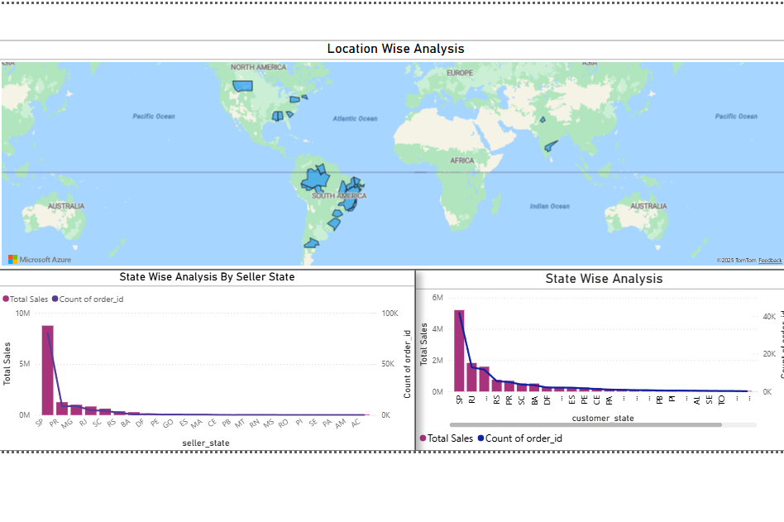
8. Yearly Revenue Growth & Seasonality Pattern.
Insight: The revenue we can see from 2016 to 2018 is consistently increasing and its became 8.7M in 2018. Trend: Quarterly analysis reveals a strong upward trend with a recurring peak in Q4, followed by a strong carry-over into Q1 of the following year.
Visualization Note:- This area and line charts represent the total seasonal sales in quarterly and yearly like Q1,Q2,Q3 and Q4, also the yearly trend is mentioned in reports. The line stacked bar represents the revenue of the year 2016 to 2018. X axis presents the order year and the Y axis is representing the total revenue.
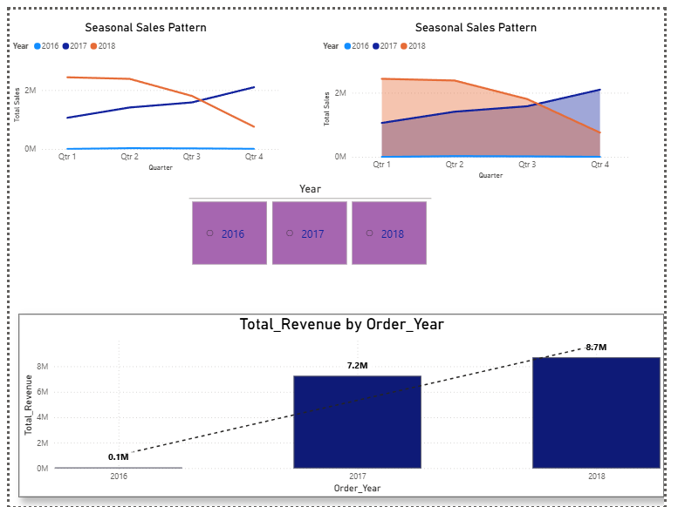
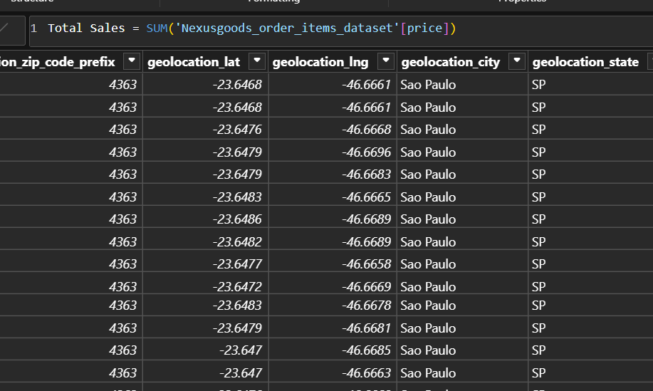
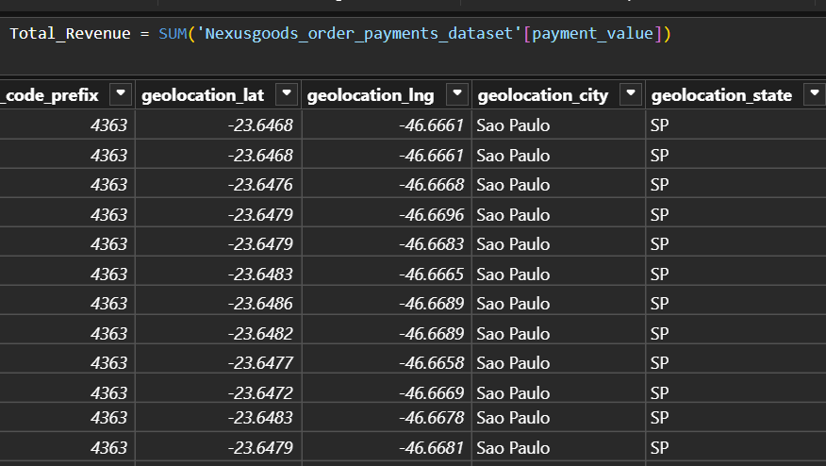

So here we can see the rapid growth form 0.1M to 8.7 M in just 2 years. Also in seasonal sales 2018 Q4 represent the loss of the company as 2017 sales was high but in 2018 q4 is showing in less numbers although 2018 was doing great in Q1.

